Chapter 18, Solution 25.

(a) g(t) = 5e^{2t}u(t)
(b) h(t) = 6e^{–2t}
(c ) 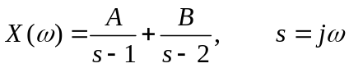

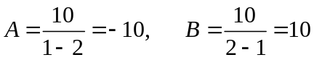
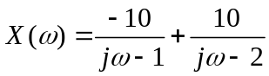
x(t) = (–10e^{t}u(t)+10e^{2t})u(t)

(a) 5e^{2t}u(t), (b) 6e^{–2t} , (c) (–10e^{t}u(t)+10e^{2t})u(t)

